**QA Intern / Trainee Software Engineer Assignment**

**Exploratory Testing Report**

**Application Tested:** job portal

1. Form Title is Misleading

* **Issue:** The form title displayed as “Student Registration Form”
* **Severity:** High
* **Steps to Reproduce:**

1. Open the live application.
2. Navigate to the form section
3. Observe the title of the form

* **Expected Behavior:** The form title should clearly reflect the purpose of the form. Such as “Job portal Form”
* **Screen shots:**

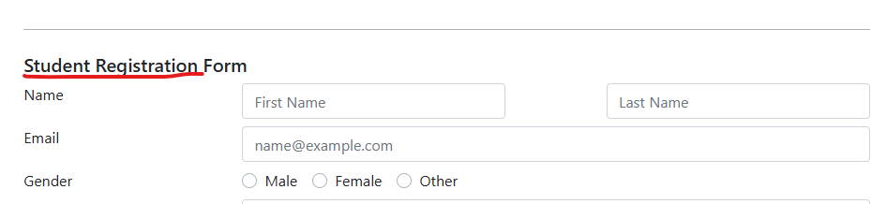

2. “Choose File “Option Allows Non-Image Files

* **Issue:** The “Choose File “button, intended for selecting a profile picture, allows non-image files such as videos (.mp4) to be uploaded.
* **Severity:** Medium
* **Steps to Reproduce:**

1. Open the Application
2. Locate the “Choose File” button for profile picture upload.
3. Select a video file from your device (ex-.mp4)
4. Notice that the form accepts the file with any validation error.

* **Expected Behavior:** The file input should restrict uploads to image formats (ex- .jpg, .png)
* **Screen shots:**



3. Missing Placeholder Text in input Fields

* **Issue:** Some input fields (ex- Address, Subjects) lack placeholder text, which could help users understand the expected format.
* **Severity:** Medium
* **Steps to Reproduce:**

1. Open the Application
2. Navigate to the form input fields
3. Observe that no placeholder text is provided in fields like Address and Subjects.

* **Expected Behavior:** Placeholder text should be added in fields to guide users ( address example-> 20,Kaluthara,Sri Lanka , subject examples-> Maths, English)
* **Screen shots:**

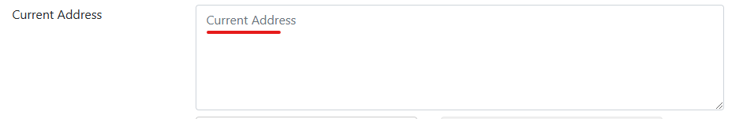

4. No Clear Identification of Main Inputs

* **Issue:** The form does not visually indicate which input are mandatory (ex- Name, Email, Mobile Number)
* **Severity:** High
* **Steps to Reproduce:**

1. Open the Application
2. Observe the input fields
3. Notice that there are no indicators (ex- asterisks or ‘required’ labels) for mandatory fields.

* **Expected Behavior:** Mandatory fields should be clearly marked with an asterisk (*) or “required” label.
* **Screen shots:**

